GeoDT User Guide
Dr. Luke P. Frash
Los Alamos National Laboratory
This guide explains model setup and payoff interpretation for Geothermal Design Tool (GeoDT) and Geothermal Design Tool Interactive (GeoDTi). Please note this is a working document and therefore subject to change. Feedback and questions are appreciated.

Overview
The interactive panel for GeoDT 4.X provides the most commonly used controls to setup, run, and inspect the outcomes for conceptual designs for geothermal reservoir development (Figure 1). The layout is intended for rapid iteration to help you to refine your development strategy. Complete the following steps to get started. Note that the most common first-run errors tend to be incompatible python libraries or conflicts with security software, so check for those potential issues first. We use Anaconda 3.X to execute our core code.
- Select “Run Batch”
- Select “Refresh Statplot”
- Right click to select a result from the scatter plot
- Explore, edit, and iterate
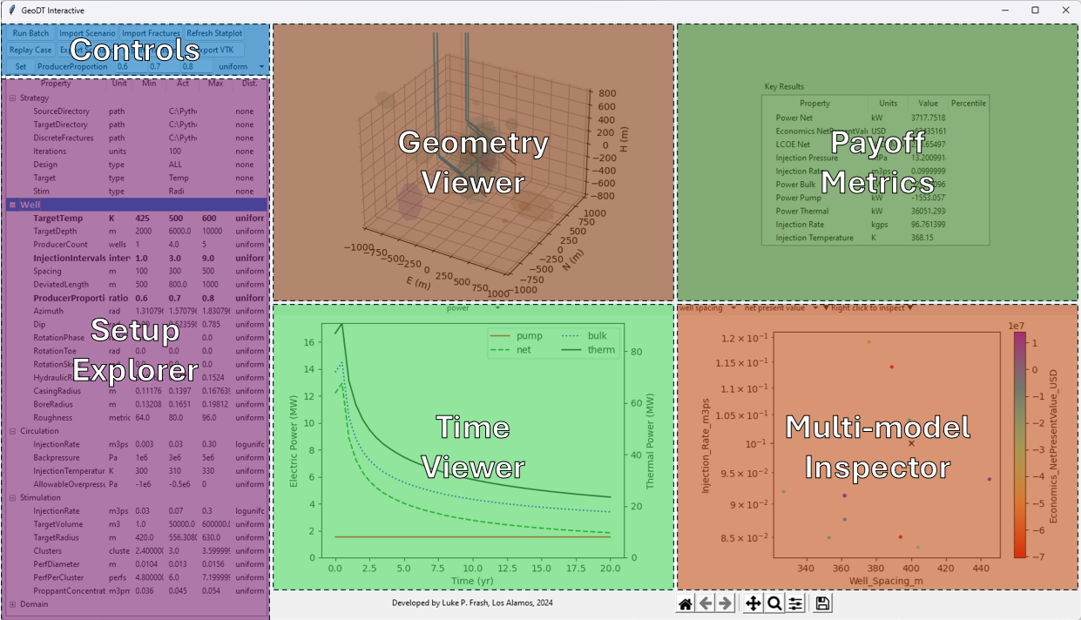
Figure 1: Layout for GeoDT for iterative geothermal reservoir design and optimization.

Setup
GeoDT includes a multitude of physical processes that are meant to approximate the complexity of deep geothermal systems, but without requiring detailed knowledge about the specific site. This is made possible by our database of general rock properties (Table 1). When the details are unknown about a site, we recommend using broad uncertainty ranges to assess the full range of possibilities. To do this, subject matter expertise and reasonable assumptions can be beneficial in some cases. GeoDT can be deployed to help identify those cases through trial-and-error, sensitivity analysis, or in conjunction with machine learning or artificial intelligence tools. Likewise, GeoDT can be used for hypothesis testing to help quantify changes in performance optimization and uncertainty when given scenarios that assume the acquisition of future site data (e.g., in-well stress data).
Table 1: Model inputs and default ranges for reservoir modeling.

Payoff (Outputs)

Structure

Validation

